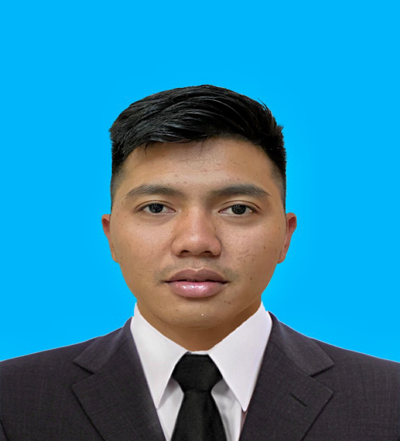**JIMMY R. LOQUINARIO**

P-Lumbia Brgy. Malinao Gingoog City Misamis Oriental

9014 Philippines

[jimmyloquinario@icloud.com](mailto:jimmyloquinario@icloud.com)

+639672416999

**CAREER OBJECTIVE:**

To obtain a position that would fit on my qualification.

To develop further my talents and skills for continues career improvement, and to be part of the company.

**PROFESSIONAL SUMMARY:**

Accomplished and energetic waiter with a solid history of achievement in food handling. Hardworking, resourceful, creative, and willing to learn, work well under pressure, can work as part of a team, can adjust any types of personalities, and willing to work overtime.

**WORK EXPERIENCE:**

Waiter , Coffee maker

**Cafè vergnano Alkhobar Saudi Arabia**

February 1 2021 – february 2 2023

**Waiter**

Dip N Dip Chocolate Bar and Café Riyadh Saudi Arabia

March 28, 2019 – March 29, 2020

**Waiter**

Mandarin Palace Restaurant Paranaque City

Feb 18,2018 – March 20,2019

**Waiter**

Tao Yuan Restaurant Resorts World Manila

July 17, 2016- Nov 30, 2017

**Dishwasher**

Tao Yuan Restaurant Resorts World Manila

Dec 16, 2015 – July 16, 2016

**Welder**

Edwamepa Welding shop

June 5, 2014- Nov 20, 2015

**SKILLS:**

Service Oriented

Food Handling

Active listening and speaking

Public safety and security

**EDUCATIONAL ATTAINMENT:**

Tertiary;2011- 2012 Automotive and welding technology

Goodwill technical skills and computer school

Gingoog city misamis oriental

Secondary; 2010 2011 Malinao national high school

Gingoog city misamis oriental

Primary;2006 2007 Malinao elementary school

Gingoog city misamis oriental

**PERSONAL INFORMATION:**

Born; September 13 1994

Place of birth; Mauylab bontoc southern leyte

Citizenship; Filipino

Martial status; Single

Religion; Catholic

Height; 5’8

Weight; 65 kg

Gender; Male

Language; English, Tagalog ,Bisaya and little Arabic language

**CHARACTER REFERENCES:**

Francis Garcia

Production manager

[f.garcia@janburger.com](mailto:f.garcia@janburger.com)

+966540353571

Marvin Saez

Captain waiter mandarin palace restaurant

[Marvin.saez.3@yahoo.com](mailto:Marvin.saez.3@yahoo.com)

Sheena Dawatan

HR Tao yuan restaurant

[Dawatansheena@yahoo.com](mailto:Dawatansheena@yahoo.com)

Clark Perez

Supervisor Tao yuan restaurant

+639773245933

JIMMY R. LOQUINARIO

Applicant signature